CIVIL AIR PATROL
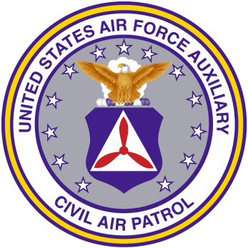

UNITED STATES AIR FORCE AUXILIARY

MARY FEIK
ACHIEVEMENT RIBBON

PRESENTED TO

C/SrA [NAME]

FOR SUCCESSFUL COMPLETION OF ALL
REQUIREMENTS OF ACHIEVEMENT 3
IN THE CIVIL AIR PATROL CADET PROGRAM

Given this day of [MONTH], [YEAR]

________________________
[NAME], [GRADE], CAP
[TITLE]
[SQUADRON/GROUP/WING NAME]

