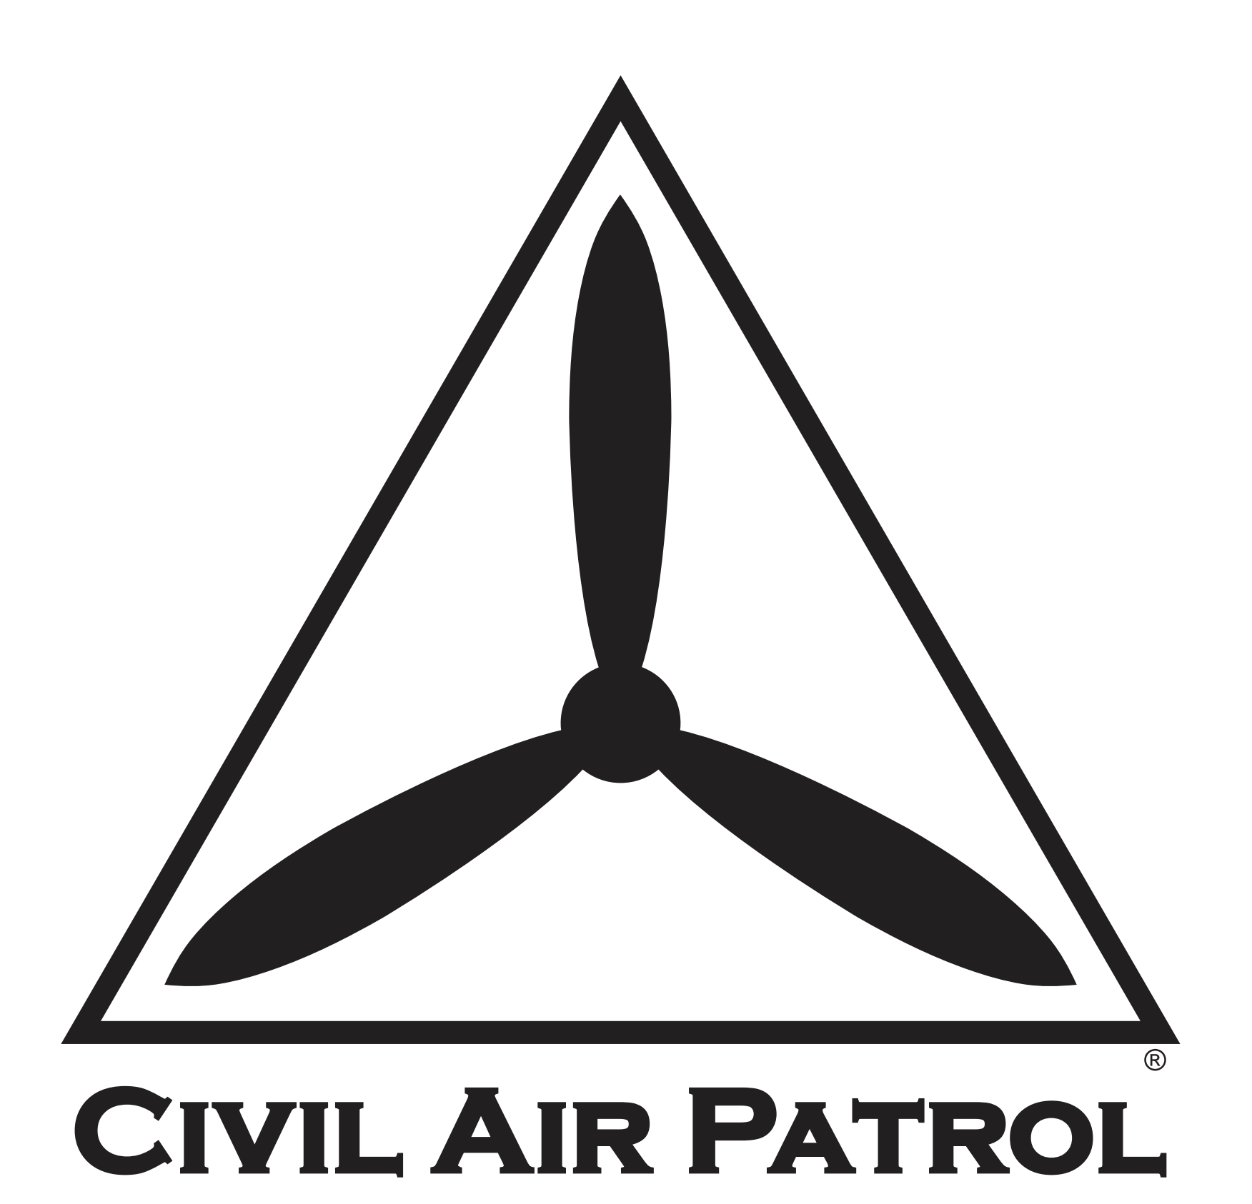

Post-COVID-19 Remobilization of the Membership Plan
  - Phase II: Resuming One-Day Special Activities (AE Events, SAREXs, etc)

XXWG
Completed dd MMM 2021

Template Updated 10 February 2021

This plan has been developed for ____(SPECIFY)_____ Wing, using the template provided by the Civil Air Patrol National Headquarters to enter Phase II, Resuming One-Day Special Activities.

Additional staffing and resources have been coordinated with _ (other wing or region, if applicable)_, to cover gaps in this wing’s available resources.

NOTE: Deviations from the template are authorized, but should be coordinated by contacting the COVID-19 Planning Team at COVID-19Plans@capnhq.gov.

Plan Coordinator and Point of Contact: _(e.g., Staff Officer or Incident Commander Appointed)_

Primary Phone: (____) _____ - ________

Primary Email: ____________@______________________.____

Narrative Summary of Coordination and Events To-Date in _(State)_ Wing:

_________(Complete below, and on additional pages as-needed.)__________

Phase II: Resuming One-Day Special Activities (AE Events, SAREXs, etc)
NOTE: Resuming one-day special activities will not be done before it has been deemed appropriate to resume regularly scheduled meetings (i.e., this will start in Phase II).
Item# | Task | OPR/Assigned Personnel | Date Tasked | Suspense | Date Completed | Notes
2.1. | Wing Commanders should review their wing calendar for previously-postponed and upcoming day-only events
2.1.1. | Wing priorities for training events should be coordinated with unit commanders’ needs
2.1.2. | Task staff officers to provide input on list of events and priorities:
2.1.2.1. | Director of Aerospace Education
2.1.2.2. | Director of Cadet Programs
2.1.2.3. | Director of Operations/Emergency Services
2.1.2.4. | Director of Professional Development
2.1.2.5. | Plans and Programs Officer
2.2. | Coordinate with subordinate unit leaders to deconflict calendar events to the greatest extent possible
2.3. | Publish updated event listings to the Wing calendar and promote these dates to the units for their planning and participation
2.4. | Task the Director of Safety to coordinate with Activity Directors
NOTE: | The term “Activity Directors” may include Incident Commanders that are directing exercises. Incident Commanders should use existing operational guidance for real-world missions and taskings. Use good judgement.
2.4.1. | Activity Directors will use Post-COVID-19 produced Risk Management (RM) forms to mitigate local risks
2.4.2. | Activity Directors identify sources for face coverings & sanitizer to use in case of a return to increased risk

Phase II: Resuming One-Day Special Activities (AE Events, SAREXs, etc; continued)

Item# | Task | OPR/Assigned Personnel | Date Tasked | Suspense | Date Completed | Notes
2.5. | Task the Health Service Officer to coordinate with Activity Directors
2.5.1. | Health Service Officers consider screening with no-touch thermometers at events (if such equipment is available and practical)
2.5.2. | Health Service Officers remind members that identify as High-risk to remain home, but participate virtually
2.5.3. | Health Service Officers ensure that there is a cleaning/sanitizing plan for commonly touched surfaces, a hand washing plan, a face covering plan, a temperature check plan (either performed prior to entering the activity with a no-touch thermometer or performed at home prior to coming to the activity), and a social distancing plan.
2.5.4. | Units will ensure no more than 50 members are together at gatherings. Squadrons with more than 50 members must submit a plan on how they will comply with restrictions
2.6. | Ensure Activity Directors have plans in place to communicate last-minute cancellations of events to participants
2.7. | Ensure Activity Directors have plans in place to conduct verification of local public health guidance, local weather, and any other information that may lead to event cancellation (Continuation Check)
2.7.1. | 45 Days Prior Continuation Check
2.7.2. | 14 Days Prior Continuation Check
2.7.3. | 7 Days Prior Continuation Check
2.7.4. | 1 Day Prior Continuation Check
2.7.5. | Day-Of Continuation Check

Phase II: Resuming One-Day Special Activities (AE Events, SAREXs, etc; continued)

Item# | Task | OPR/Assigned Personnel | Date Tasked | Suspense | Date Completed | Notes
2.8. | Ensure Unit Commanders are aware of and following the same procedures for unit-only single-day activities (i.e., they are the Activity Director for the purposes of this checklist, for unit events)
2.9. | Email this plan to signal intentions to resume single-day events to the CAP COVID-19 Planning Team at  COVID-19Plans@capnhq.gov, and copy the Region Commander
2.9.1. | Briefly describe/summarize previous coordination accomplished (i.e., 2.1 through 2.8 above)
2.9.2. | Verify no jurisdictional restrictions are in place from State or Local Governments
2.9.3. | Set date to resume one-day special activities
2.9.4. | Receive approval from the CAP COVID-19 Planning Team to resume one-day special activities. Plan for one-week lead time.
2.10. | Publish the date that one-day special activities will resume to subordinate units
2.11. | Task Wing Director of Operations to communicate the following to subordinate units
2.11.1. | Identify flight operations permitted during Remobilization Phase II
2.11.2 | Identify requirements (Currency, etc) for Senior members
2.11.3 | Identify cadet training requirements that may be different than Phase I requirements
2.11.4 | Identify cleaning standards for aircraft and vehicles before and after use

