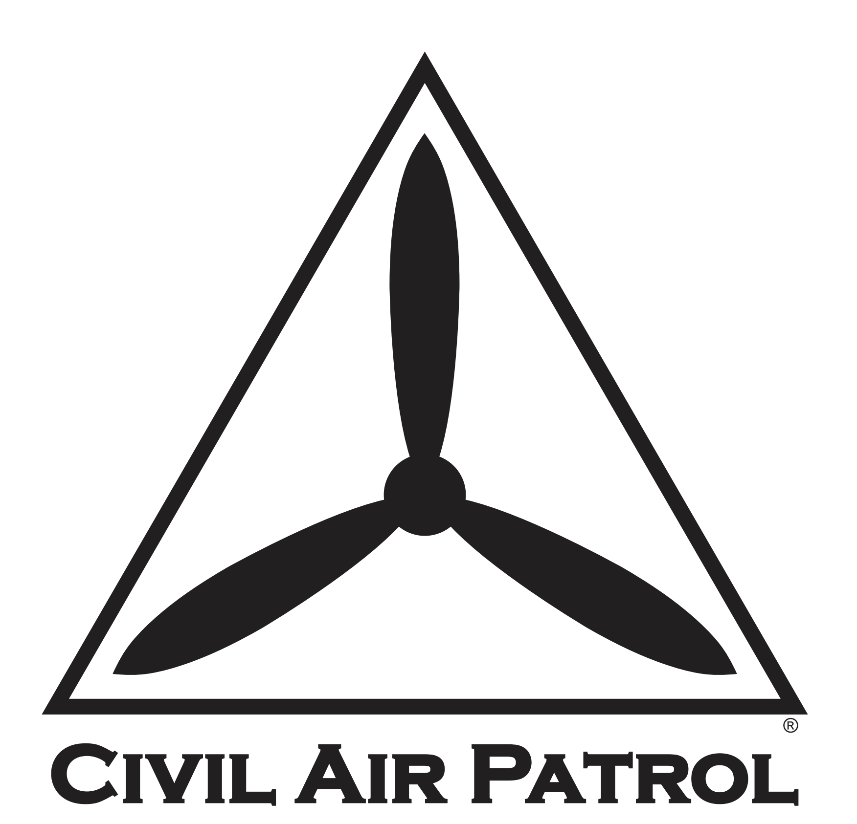

Post-COVID-19 Remobilization of the Membership Plan
  - Phase I: Resuming Regularly Scheduled Meetings

XXWG
Completed dd MMM 2021
Template Updated 10 February 2021
This plan has been developed for ____(SPECIFY)_____ Wing, using the template provided by the Civil Air Patrol National Headquarters to enter Phase I, Resuming Regularly Scheduled Meetings.

Additional staffing and resources have been coordinated with _ (other wing or region, if applicable)_, to cover gaps in this wing’s available resources.

NOTE: Deviations from the template are authorized, but should be coordinated by contacting the COVID-19 Planning Team at COVID-19Plans@capnhq.gov.

Plan Coordinator and Point of Contact: _(e.g., Staff Officer or Incident Commander Appointed)_

Primary Phone: (____) _____ - ________

Primary Email: ____________@______________________.____

Narrative Summary of Coordination and Events To-Date in _(State)_ Wing:

_________(Complete below, and on additional pages as-needed.)__________

Phase I: Resuming Regularly Scheduled Meetings

Item# | Task | OPR/Assigned Personnel | Date Tasked | Suspense | Date Completed | Notes
1.1. | Verify state government guidance currently allows or will allow gatherings on the date proposed for resuming meetings (Review of overall directives in impacted state)
1.2. | Hold meeting with between Plan Coordinator and Health Services Officer
1.2.1. | Wing priorities for training events should be coordinated
1.2.1.1. | Check state and local health guidance regarding gatherings (Review of each jurisdiction impacted by this plan)
1.2.1.2. | Prepare information for subordinate units on temperature screening, health education, and sanitation
1.2.2 | Consult with Wing Legal Officer about resuming meetings
1.2.3 | Coordinate with Wing Director of Safety
1.2.3.1 | Verify proper risk planning tools are available to units
1.2.3.2 | Prepare to communicate with subordinate units on Safety-related matters (see 1.7. below)
1.2.4 | Coordinate with Wing Director of Cadet Programs
1.2.4.1 | Prepare recommendations for units regarding meeting activities and alternatives to maintain optimal distance while at meetings
1.2.4.2 | Prepare bullets for units to incorporate when sending messages to parents about the resumption of meetings

Phase I: Resuming Regularly Scheduled Meetings (Continued)

Item# | Task | OPR/Assigned Personnel | Date Tasked | Suspense | Date Completed | Notes
1.3. | Have subordinate unit commanders verify that local governments do not have more restrictive social-distancing  guidelines than those at the state level
1.4. | Send copy of planning documents to the CAP COVID-19 Planning Team at  COVID-19Plans@capnhq.gov, and copy the Region CC to reinstate meetings.
1.4.1. | Briefly describe/ summarize previous coordination accomplished
1.4.2. | Verify no jurisdictional restrictions are in place from State or Local Governments
1.4.3. | Set date to resume meetings; this is also the start of Phase II.
1.5. | Receive approval from the CAP COVID-19 Planning Team to reinstate meetings. Plan for one-week lead time.
1.6. | Publish the date that meetings may resume to subordinate units
1.7. | Task Wing Director of Safety to communicate the following to subordinate units
1.7.1. | Units will review CAPFs 160, 160S, and 160HL to be sure COVID-19 risks are considered and mitigated
1.7.2. | Unit Safety Officers s will emphasize continued use of face coverings and hand sanitizer, as well as social distancing, hand washing and surface cleaning/disinfection
1.8. | Task Wing Health Service Officer to communicate the following to subordinate units:

Phase I: Resuming Regularly Scheduled Meetings (Continued)

Item# | Task | OPR/Assigned Personnel | Date Tasked | Suspense | Date Completed | Notes
1.8.1. | Units will ensure no members or guests with a temperature of 100.4 or greater are admitted (a temperature at or above 100.4°F is the CDC recognized point where there is a fever). Units will require members to take their temperature at home or may screen with no-touch thermometers prior to entry.
1.8.2. | Educate members on their stratified level of risk (i.e., Low-risk vs. High-risk)
1.8.3. | Units perform all appropriate public health measures (e.g., social distancing, surface cleaning/disinfection, face coverings, hand sanitizer, at-home temperature check or no-touch temperature check prior to entry and routine symptom checks)
1.8.4 | Units will ensure no more than 10 members are together at gatherings. Squadrons with more than 10 members must submit a plan on how they will comply with restrictions
1.9. | Task Wing Director of Cadet Programs to communicate the following to subordinate units:
1.9.1. | Units identify ways to meaningfully engage and fully participate in meetings without formations, drill, or other close-distance activities
1.9.2. | Units draft a local message to parents to inform them about what CAP is doing to keep Cadets safe while they participate
1.10. | Task Wing Director of Operations to communication the following to subordinate units.
1.10.1 | Identify flight operations permitted during Phase I
1.10.2. | Identify requirements (Currency, etc) for senior members
1.10.3. | Identify requirements for cadets that have earned their Private Pilot's License to return to flying
1.10.4. | Identify requirements for cadets training to earn their Private Pilot's License
1.10.1. | Identify cleaning standards for aircraft and vehicles before and after use

